Almalence Gui

General overview
OpenCamera Almalence gui implemented in a native modern look.
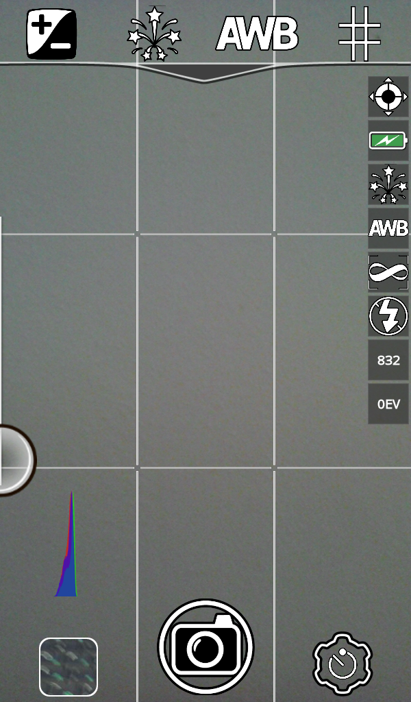
Main part of GUI is viewfinder with different controls.

Bottom controls
Bottom controls contains last captured image, shutter button and mode selector button (with indication of current mode. See picture 1).

Top controls
Top controls contains quick settings buttons. Quick settings provide fast access to the main functionality controls and to special mode's controls.
Top menu has complex behavior and support click, long click and sliding. On click you can select value of desired setting. On Long click you can configure top panel – select most wanted settings. On sliding from top to bottom – you will see all available quick settings.

VF controls
Viewfinder controls can be of different types:
  - central
  - top
  - bottom
  - etc

Preferences
Main preferences screen build of headers. Headers hides main groups of settings.
Currently all settings available. You can even configure functionality which is not available in currently active mode.

Picture 1. Mode selection
